1. Some of the records not display in Salary generator 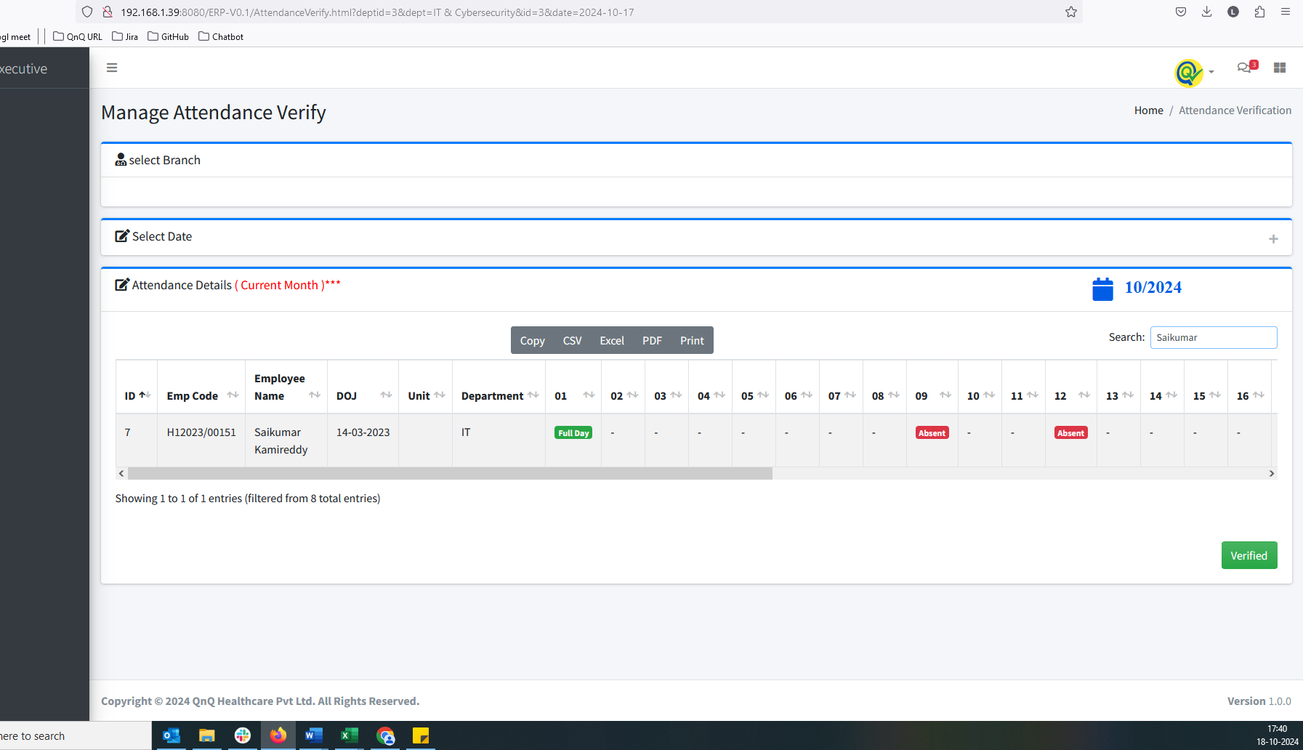
2. Some of the records not display in Salary generator 

  